PRACTICAL 5
Aim: Implementation of knapsack algorithm using dynamic programming.
Algorithm:
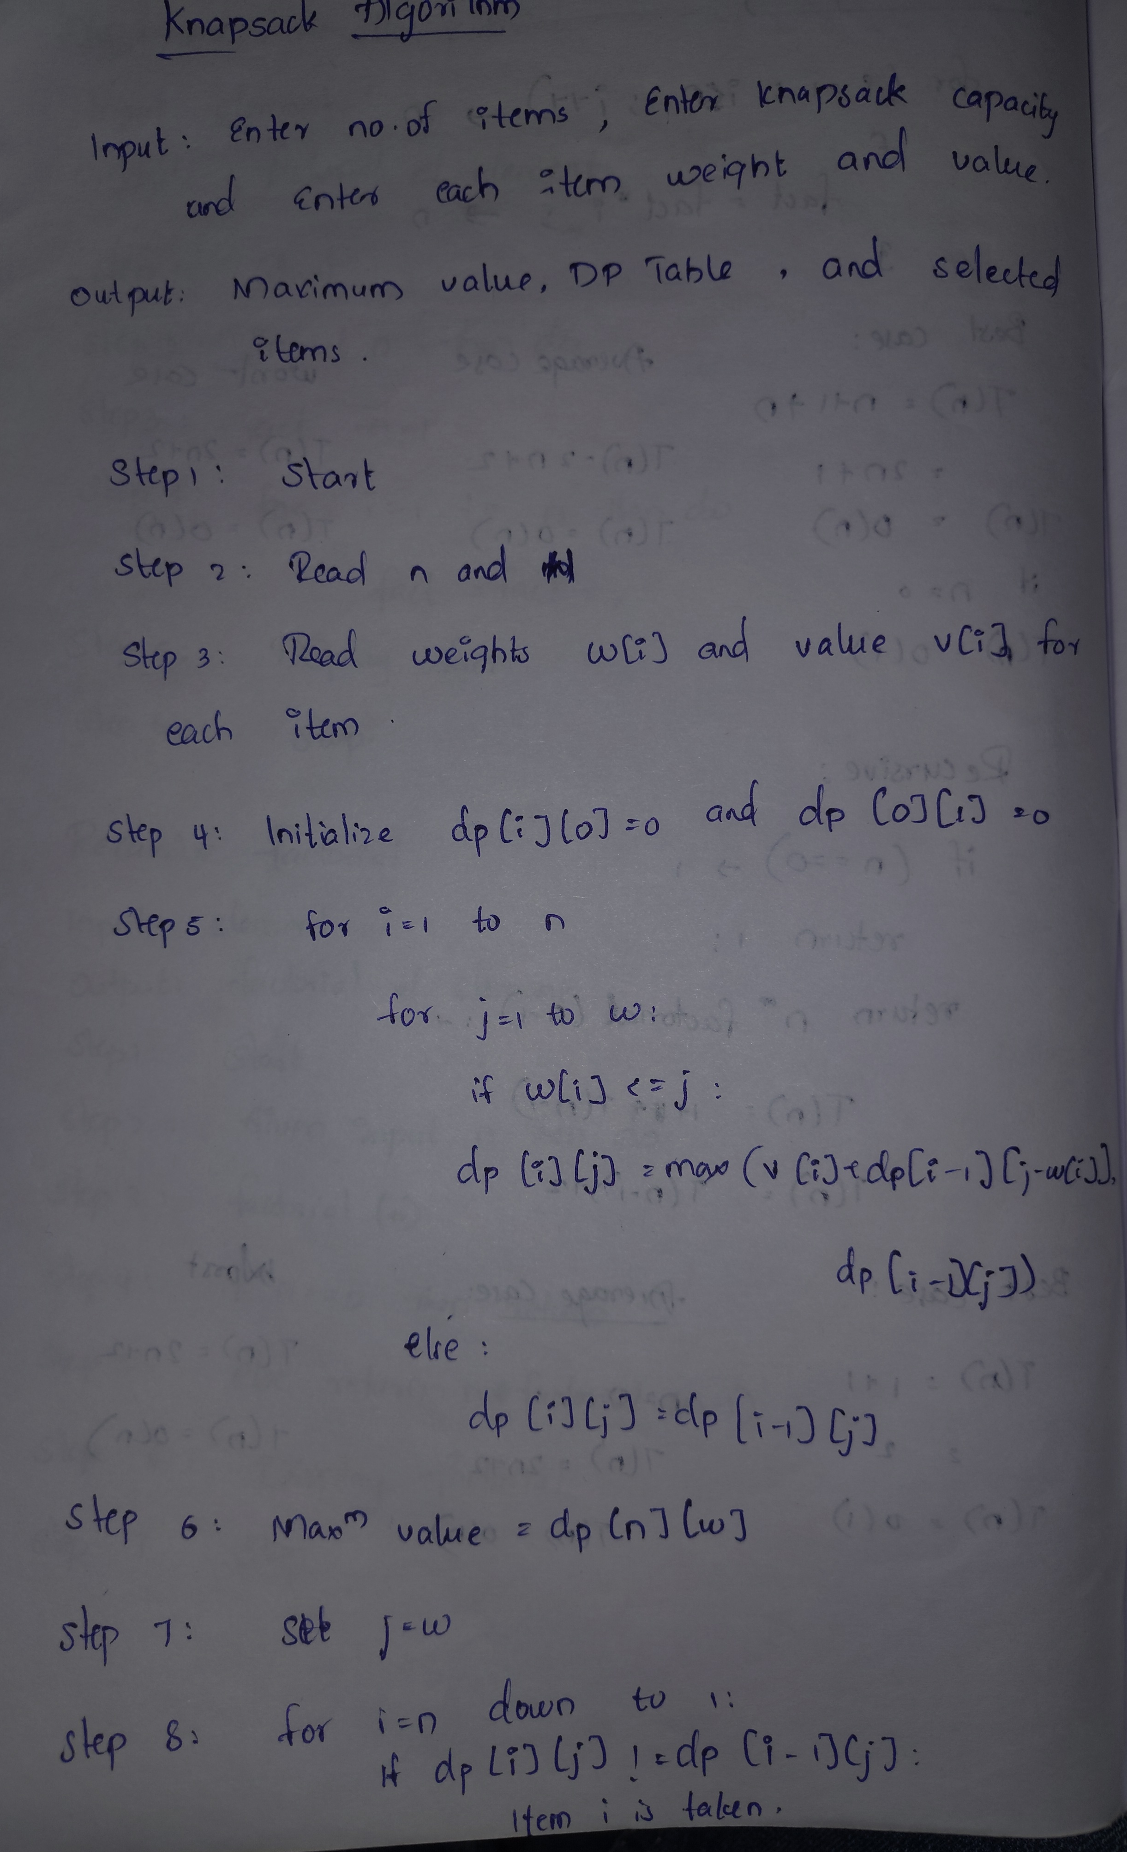
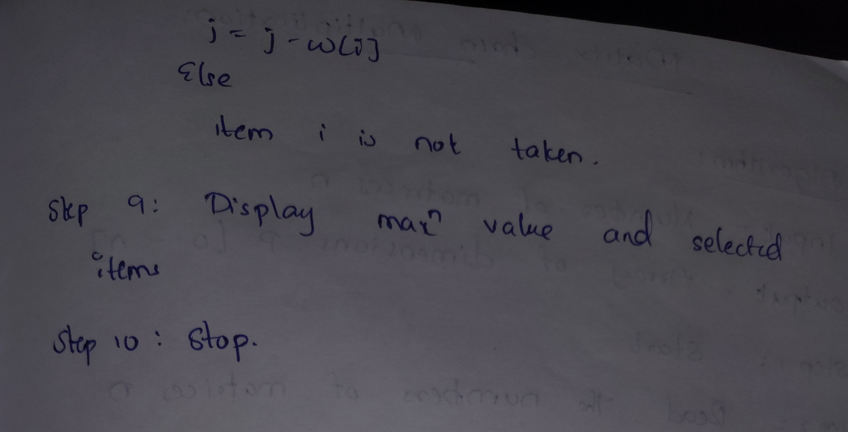
Program / Code:
#include<iostream>
using namespace std;

class Knapsack {

private:
int w[10]; // weights
int v[10]; // values
int n; // number of items
int W; // capacity
int dp[10][100]; // dp table

public:

// ── Get Input ──
void getInput() {
cout << "Enter number of items : ";
cin >> n;
cout << "Enter knapsack capacity : ";
cin >> W;
for(int i = 1; i <= n; i++) {
cout << "Item " << i << " weight and value : ";
cin >> w[i] >> v[i];
}
}

// ── Build dp table ──
void solve() {

// base case — row 0 and col 0
for(int i = 0; i <= n; i++) dp[i][0] = 0;
for(int j = 0; j <= W; j++) dp[0][j] = 0;

// fill table
for(int i = 1; i <= n; i++) {
for(int j = 1; j <= W; j++) {

if(w[i] <= j) {
// take or not take
dp[i][j] = max(
v[i] + dp[i-1][j-w[i]],
dp[i-1][j]
);
} else {
// cannot take item i
dp[i][j] = dp[i-1][j];
}
}
}
}

// ── Print dp table ──
void printTable() {
cout << "\nDP Table:" << endl;
cout << " ";
for(int j = 0; j <= W; j++)
cout << j << " ";
cout << endl;

for(int i = 0; i <= n; i++) {
cout << "i=" << i << " ";
for(int j = 0; j <= W; j++)
cout << dp[i][j] << " ";
cout << endl;
}
}

// ── Find selected items ──
void findItems() {
cout << "\nSelected Items:" << endl;
int j = W;
for(int i = n; i >= 1; i--) {
if(dp[i][j] != dp[i-1][j]) {
cout << "Item " << i
<< " (w=" << w[i]
<< ", v=" << v[i]
<< ") TAKEN " << endl;
j = j - w[i];
} else {
cout << "Item " << i
<< " (w=" << w[i]
<< ", v=" << v[i]
<< ") NOT taken " << endl;
}
}
}

// ── Show result ──
void showResult() {
cout << "\nMaximum Value = "
<< dp[n][W] << endl;
}
};

// ── MAIN ──
int main() {

Knapsack k;

k.getInput();
k.solve();
k.printTable();
k.showResult();
k.findItems();

return 0;
}

Time Complexity:

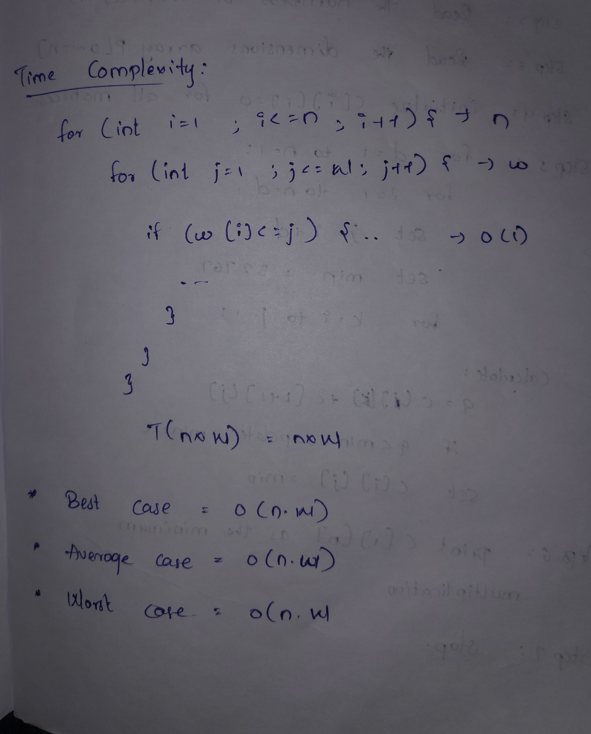

Conclusion: The 0/1 Knapsack problem was successfully implemented using Dynamic Programming. The algorithm calculates the maximum possible value within the given capacity and identifies the items that should be selected.

